A task, **T**, on the other hand, can be defined as a two-element tuple of the label space, **γ**, and objective function, **η**. The objective function can also be denoted as**P(γ| Χ)** from a probabilistic view point.

This passage defines a **task (T)** in machine learning using a mathematical concept called a **tuple**. Let's break it down:

* **Task (T):** This represents a specific learning or prediction problem you want your machine learning model to address. For instance, classifying emails as spam or not spam, recognizing handwritten digits, or predicting house prices are all examples of tasks.

**Components of a Task:**

The task is defined as a tuple containing two elements:

1. **Label Space (γ):** This refers to the set of all possible outcomes or labels that your model needs to predict. In the email spam example, the label space (γ) would be {"spam", "not spam"}.
2. **Objective Function (η):** This function essentially captures the goal you want your model to achieve. It defines how "good" a prediction is for a given task.

**Probabilistic Viewpoint (P(γ|Χ)):**

The passage mentions an alternative way to represent the objective function using a probabilistic notation (P(γ|Χ)). Here's how to interpret it:

* **P(γ|Χ):** This notation reads as "the probability of label γ given data point X." In simpler terms, it represents the desired probability distribution between the labels (γ) and the data points (Χ) you're working with.

**Essentially, the probabilistic view of the objective function focuses on how well your model can predict the correct label (γ) for a given data point (Χ).**

**Example:**

Imagine you're building a model to classify images as cats or dogs. The label space (γ) would be {"cat", "dog"}. The objective function (η) could be designed to maximize the probability of predicting "cat" for a true cat image and "dog" for a true dog image (P("cat" | Cat Image) and P("dog" | Dog Image) should be high).

Understanding tasks and their components is crucial in machine learning because:

* **Choosing algorithms:** Different algorithms are suited for different types of tasks based on the label space and objective function.
* **Evaluating performance:** The objective function helps you assess how well your model performs on the task by measuring its ability to achieve the desired outcome.

By defining tasks this way, you can clearly communicate the learning objective to your model and select the appropriate tools to achieve it.

Definition and concept of the Metaverse  
The Metaverse is a concept that's still evolving, but here's a breakdown of its key characteristics:

**Immersive and Persistent:**

* Imagine a three-dimensional virtual world where users can have a sense of "being there." This immersion is often facilitated by virtual reality (VR) headsets that create a realistic experience.
* The Metaverse is envisioned as persistent, meaning it continues to exist and evolve even when individual users log off. This allows for a constantly running virtual world with its own digital ecosystems.

**Social and Interactive:**

* The Metaverse is designed to be a social space where users can interact with each other in real-time through avatars (digital representations of oneself). These interactions could involve socializing, playing games, working collaboratively, or attending virtual events.

**Blending Physical and Virtual:**

* Some proponents envision the Metaverse as eventually merging aspects of the physical and virtual worlds. This could involve augmented reality (AR) technologies that overlay digital elements onto the real world.

**Economic Activity:**

* The Metaverse is seen as having its own digital economies. Users could potentially buy and sell virtual goods and services using cryptocurrencies or other digital tokens.

**Current State:**

* It's important to note that the Metaverse isn't a single, unified platform yet. There are various existing virtual worlds and online games with some of these characteristics. The concept is still under development, and the exact form it will take in the future remains to be seen.

**Potential Applications:**

* The potential applications of the Metaverse are vast and still being explored. Here are some possibilities:
  + **Social Interaction:** Connecting with friends and family in virtual spaces.
  + **Gaming and Entertainment:** Immersive gaming experiences and virtual concerts.
  + **Work and Education:** Attending virtual meetings, conferences, or even conducting training simulations.
  + **E-commerce:** Trying on clothes virtually or attending virtual showrooms.

**Challenges and Concerns:**

* There are also challenges and concerns surrounding the Metaverse, such as issues around privacy, security, and potential social isolation. The ethical implications and regulations for these virtual worlds will need to be addressed as the concept develops.

Overall, the Metaverse represents an evolving concept for a future iteration of the internet, potentially offering new ways to connect, work, and play in a virtual environment.

Characteristics and components of the Metaverse

The Metaverse is a broad concept, and there's no single agreed-upon definition yet. However, several key characteristics and components are likely to be part of it:

**Characteristics:**

* **Immersive and Persistent:** Imagine a 3D virtual world where users feel "present" through VR or other interfaces. This virtual world would exist and evolve even when individual users log off, creating a persistent environment.
* **Social and Interactive:** The Metaverse is envisioned as a social space where users can interact through avatars. This could involve socializing, working together, playing games, or attending virtual events.
* **Blending Physical and Virtual:** The lines between physical and virtual might blur with Augmented Reality (AR) technology overlaying digital elements onto the real world. Think virtual objects interacting with your physical environment.
* **Economic Activity:** The Metaverse could have its own digital economies. Users might buy and sell virtual goods or services using cryptocurrencies or other digital tokens.

**Components:**

* **Hardware:** This includes VR headsets, AR glasses, haptic suits (to provide touch sensations), and other peripherals that create the immersive experience.
* **Software:** The software powering the Metaverse would encompass complex virtual world simulations, game engines, and tools for creating and interacting with virtual objects and environments.
* **Network Infrastructure:** A robust and high-speed network infrastructure is crucial for supporting the massive amount of data transfer required for a seamlessly functioning Metaverse.
* **Content and Applications:** A vast ecosystem of user-generated content, applications, and experiences would populate the Metaverse. This could include games, social spaces, virtual marketplaces, and even educational applications.
* **Standardization and Interoperability:** For the Metaverse to function as a cohesive whole, there's a need for standards to ensure different platforms and experiences can work together seamlessly. This would allow users to move between virtual spaces with their avatars and belongings.

**Current State:**

It's important to remember that the Metaverse is not a single, unified platform yet. There are various existing virtual worlds and online games that offer some of these characteristics. The concept is still under development, and the exact form it will take in the future remains to be seen.

**Future Potential:**

The potential applications of the Metaverse are vast:

* **Social Interaction:** Connecting with people in more immersive ways beyond video calls.
* **Work and Education:** Attending virtual meetings, conferences, or even conducting training simulations in a realistic environment.
* **Entertainment:** Experiencing games, concerts, and other forms of entertainment in a more interactive way.
* **E-commerce:** Trying on clothes virtually or attending virtual showrooms.

**Challenges and Concerns:**

* Privacy and security issues related to user data in these virtual spaces.
* Potential for social isolation if the physical world is neglected in favor of the virtual.
* Ethical considerations and regulations regarding online interactions and economies within the Metaverse.

The development of the Metaverse will likely raise many questions and require solutions to ensure a safe, inclusive, and positive experience for all users.

Challenges and opportunities in the Metaverse ecosystem

The Metaverse holds immense potential, but it also comes with significant challenges that need to be addressed. Here's a breakdown of both sides of the coin:

**Challenges:**

* **Technical limitations:** Current VR and AR technology can be expensive, bulky, and not very user-friendly. Additionally, the network infrastructure required for a seamless Metaverse experience with millions of users simultaneously might not be readily available in all regions.
* **Privacy and Security Concerns:** The Metaverse will likely collect a vast amount of user data, including biometrics and personal interactions. Ensuring robust security measures and user privacy controls will be crucial.
* **Standardization and Interoperability:** Without common standards, users might be locked into specific platforms, hindering the concept of a unified Metaverse. Avatars, digital assets, and currencies might not work seamlessly across different virtual spaces.
* **Content Moderation and Regulation:** The Metaverse, like any online space, needs effective content moderation to prevent harassment, hate speech, and illegal activity. Developing regulations for online interactions within the Metaverse will be complex.
* **Accessibility and Inequality:** Access to VR/AR hardware and high-speed internet could exacerbate the digital divide, potentially excluding certain demographics from fully experiencing the Metaverse.

**Opportunities:**

* **Enhanced Social Interaction:** The Metaverse allows for richer social experiences beyond video calls. Imagine attending virtual concerts with friends or collaborating on projects in immersive workspaces.
* **Revolution in Work and Education:** Virtual meetings, conferences, and training simulations could become more engaging and interactive in the Metaverse. Educational experiences could be transformed with immersive historical simulations or virtual field trips.
* **Evolving Entertainment:** Gaming, concerts, museums, and other forms of entertainment could become more interactive and immersive in the Metaverse. Imagine attending a virtual concert where you feel like you're part of the crowd.
* **Economic Growth and Innovation:** The Metaverse has the potential to create new job opportunities and industries related to content creation, virtual goods, and Metaverse infrastructure development.
* **Increased Accessibility:** For people with physical limitations, the Metaverse could offer new ways to connect and participate in activities that might be difficult in the real world.

**Overall, the Metaverse presents a fascinating future with exciting possibilities for various aspects of our lives. However, overcoming the technical hurdles, ensuring user safety and privacy, and establishing ethical frameworks will be crucial for its success. The Metaverse holds the potential to create a more connected and immersive world, but it's important to navigate its development responsibly.**

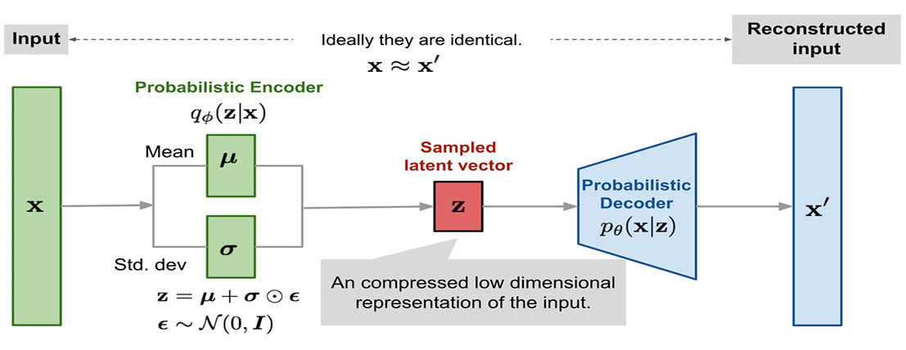

The image you sent depicts a block diagram of a variational autoencoder (VAE), a type of neural network architecture that encodes data into a latent space while capturing the statistical properties of the data. Here's a breakdown of the key components and their relationships:

**Input (x):** This represents the raw data point that the VAE will process. In the example you provided, it's denoted as a vector x.

**Encoder (qθ(z | x)):** This neural network takes the input x and aims to compress it into a lower-dimensional latent representation z. The notation qθ(z | x) signifies a conditional probability distribution, indicating that the distribution of possible z values depends on the specific input x. The Greek letter theta (θ) represents the weights and biases that the encoder network has learned during training to effectively map the input data to the latent space.

**Latent Space (z):** This is a lower-dimensional space compared to the original input data. It captures the essential features or compressed representation of the input x. The VAE tries to learn a latent space that effectively retains the important information from the input while discarding redundancy.

**Mean (μ) and Standard Deviation (σ):** These are mathematical values that together define a Gaussian distribution (also known as a normal distribution). The Gaussian distribution is bell-shaped and is used to represent the probability of different possible values for z given an input x. The mean (μ) indicates the center or most likely value for z, while the standard deviation (σ) controls the spread of the distribution. A larger standard deviation signifies more uncertainty and allows for a wider range of possible z values.

**Sampler (ε ~ N(0, 1)):** This part introduces randomness into the VAE. It samples a random noise vector (ε) from a standard normal distribution (where the mean is 0 and the standard deviation is 1).

**Sampled Latent Vector (z = μ + σ * ε):** By adding the sampled noise (ε) scaled by the standard deviation (σ) to the mean (μ), the VAE generates a specific point z within the latent space. This process accounts for the stochastic (random) nature of the encoder.

**Decoder (pθ(x | z)):** This neural network receives the sampled latent representation z as input and attempts to reconstruct the original input data x from it. The notation pθ(x | z) represents another conditional probability distribution, indicating that the probability of the reconstructed data x depends on the latent representation z. Just like the encoder, the decoder also has weights and biases (θ) that it learns during training.

**Reconstructed Input (x'):** This is the output of the decoder, which is an approximation of the original input x based on the sampled latent representation z. In an ideal scenario, the reconstructed input x' would be very similar to the original input x.

**Goal of the VAE:**

The VAE is trained to minimize the difference between the original input x and the reconstructed input x'. During training, the VAE endeavors to learn an encoder that captures the essential features of the data in the latent space and a decoder that can faithfully reconstruct the data from those latent representations. The inclusion of the random noise vector (ε) in the latent space helps the VAE learn more robust representations that generalize well to unseen data.

In essence, VAEs provide a powerful approach for learning latent representations of data that are both informative and efficient. They can be used for tasks like dimensionality reduction, data compression, anomaly detection, and even generative modeling.

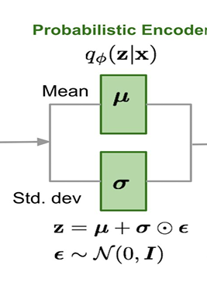

Sure, the part of the image you refer to shows the mathematical notation for the encoder in a variational autoencoder (VAE). Let's break it down:

* **qθ(z | x):** This represents the **conditional probability distribution** of the latent variable z given the input data x. It's essentially a function that takes an input x and outputs a probability density for different possible values of z.
  + **q**: This signifies a probability distribution.
  + **θ**: This denotes the **weights and biases** of the encoder network. These parameters are learned during the training process to effectively map the input data to the latent space distribution.
  + **z**: This represents the latent variable, the compressed representation of the input data in the lower-dimensional latent space.
  + **|**: This symbol reads "given" in conditional probability notation.
  + **x**: This represents the input data point.

**Key idea:** The encoder, given a specific input x, doesn't simply predict a single value for z. Instead, it estimates a whole distribution of possible z values, indicating the likelihood of each value being the latent representation for that particular input. This distribution is typically modeled as a Gaussian distribution (bell-shaped curve).